**Teigan Svederus**

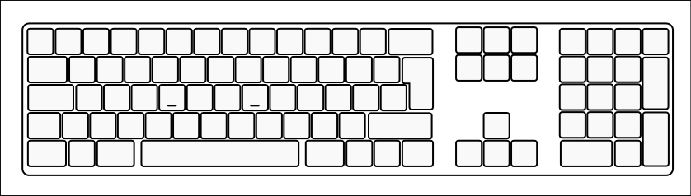

Num Key

function

App

shift

tab

Esc

Space bar

Enter

shift

Caps lock

Match the following terms with their locations on the keyboard:

* Applications Key
* Tab Key
* ESC (Escape) Key
* Enter Key
* Shift Key
* Space Bar
* Function Keys
* Numeric Keypad
* Caps Lock Key

Activity 1 – Labelling a Keyboard